**COMSATS University Islamabad,   
Abbottabad Campus**

**Project Proposal   
(SCOPE DOCUMENT)**

**for**

**<Interview Preparation Application>**  
Version 1.0

***By***

**Hozefa Hassan Rizvi CIIT/FA20-BSE-019/ATD**

**Ashar Ali CIIT/FA20-BSE-158/ATD**

**Muhammad Hammad CIIT/ FA20-BSE-031/ATD**

***Supervisor*Mam Sana Malik**

***Bachelor of Science in Computer Science (2020-2024)***

|  |  |  |
| --- | --- | --- |
| **No.** | **Comment** | **Action** |
|  |  |  |
|  |  |  |
|  |  |  |
|  |  |  |
|  |  |  |
|  |  |  |

**SCOPE DOCUMENT REVSION HISTORY**

**Supervisor Signature**

**Date:**

**Table of Contents**

**1.** **Introduction 4**

**2.** **Problem Statement 5**

**3.** **Problem Solution for Proposed System 5**

**4.** **Related System Analysis/Literature Review 5**

**5.** **Advantages/Benefits of Proposed System 6**

**6.** **Scope 6**

**7.** **Modules 6**

7.1 Module 1: User Panel 6

7.2 Module 2: Expert Panel 7

7.3 Module 3: Mock Interview 7

7.4 Module 4: Expert Panel 8

**8.** **System Limitations/Constraints 8**

**9.** **Software Process Methodology 8**

**10.** **Tools and Technologies 8**

**11.** **Project Stakeholders and Roles 9**

**12.** **Team Members Individual Tasks/Work Division 9**

**13.** **Data Gathering Approach 10**

**14.** **Concepts 10**

**15.** **Gantt chart 10**

**16.** **Mockups 11**

**17.** **Conclusion 13**

**18.** **References 14**

**19.** **Plaragism Report 14**

**Project Category: (**Select all the major domains of proposed project**)**

**A-**Desktop Application/Information System **B-**Web Application/Web Application based Information System **C-** Problem Solving and Artificial Intelligence ** D-**Simulation and Modeling ** E-** Smartphone Application ** F-** Smartphone Game ** G-** Networks ** H-** Image Processing****Other (specify category) ______________________

**Abstract**

**The “Interview Preparation Application”** is a platform used to boost the confidence of software engineering graduates in their journey towards the interview. In today’s world there is very tough competition in the market, effective interview plays a vital role to get a job and to prepare for the interview and make this process simple and boost up candidate confidence this project is going to be made. This application offers a wide range of questions and answers that were asked to previous candidates, connect the candidate with the industry experts, and past successful candidates to gain knowledge from their experience. This application focuses on user contribution and collaboration that will be helpful to make their interview successful. The project goal is to equip graduates with the skill and confidence needed to excel in software engineering interviews.

**Introduction**

The "Interview Preparation Application" is a project made especially for **software engineering graduates.** Getting a job in today's competitive world can be tough, and doing well in job interviews is a big part of that. This project is all about creating a mobile application that helps graduates prepare for interviews.

The app is designed with graduates in mind, assuming they already have some knowledge about software engineering. It's here to give them everything they need to do well in interviews. This includes a big list of questions they might be asked, a way to talk to experts, inspiring stories from people who succeeded, a place to chat with others, and even a special feature where the app checks how confident you are during practice interviews.

We believe that this app can make a real difference in helping graduates not only learn about the technical stuff but also feel more confident and ready for interviews.

**Problem Statement**

The "Interview Preparation Application" handles the challenges faced by software engineering graduates when getting ready for job interviews. Graduates often miss out on job opportunities and feel stressed because they haven't learned how to navigate the real-world job scene. Universities and colleges usually don't teach students what to expect in actual job interviews and how to behave in a professional setting.

**Problem Solution for Proposed System**

Our app does more than just provide textbook knowledge. It helps graduates bridge the gap between what they've learned in school and what they need to know for real jobs. We offer a wide range of interview resources, including insights into industry-specific interview questions and how to act professionally. Our app connects users with experienced professionals who can offer guidance. We use technology to boost users' confidence and help them succeed in interviews. Our goal is to make interview preparation easy and tailored to what graduates really need to know to succeed in the job market.

**Related System Analysis/Literature Review**

|  |  |  |
| --- | --- | --- |
| **Application Name** | **Weakness** | **Proposed Project Solution** |
| **Huru Interview Prep App** | Paid service may limit accessibility | Our application offers a free and accessible platform for interview preparation. It provides a comprehensive database of interview questions, expert insights, and collaborative features, eliminating the barrier of cost. |
| **LinkedIn** | Limited focus on interview preparation | Our application provides a dedicated space for interview preparation, ensuring users can focus specifically on enhancing their interview skills. It offers a tailored environment for interview-related interactions and resources. |
| **Dropbox** | Indirect impact on interview preparation | Our application enhances user convenience by offering secure cloud-based storage for interview-related materials. |

**Advantages/Benefits of Proposed System**

1. **Expert Advice:** Chat with experts and learn from experienced interviewees in real-time.
2. **Boosted Confidence:** Our application helps you appear more confident during interviews, regardless of your answers.
3. **Community Support:** Join a friendly community, share experiences, and get feedback.
4. **Extensive Question Bank:** Access a wide range of interview questions and answers.
5. **User Contributions:** Add your own questions and answers, and benefit from community checks.
6. **Progress Tracking:** Keep an eye on your progress and see how you're improving.

**Scope**

The "Interview Preparation Application" project encompasses a comprehensive range of functionalities aimed at revolutionizing the interview preparation experience for software engineering graduates. The project includes **user authentication** and **profile setup** to ensure secure account creation. Users gain access to an **extensive question bank**, covering relevant interview topics. **Community collaboration** features enable users to engage in discussions, share experiences, and offer feedback, fostering a supportive learning environment. The application facilitates **expert interaction**, allowing users to seek guidance from industry professionals and successful candidates. Utilizing advanced technology, the project introduces **mock interview analysis** to enhance users' interview confidence through performance evaluation**. User contribution** is encouraged through the submission of **questions** and **answers**. A dedicated **user support system** ensures assistance and feedback accessibility. The project prioritizes user-friendliness and encourages user-driven content moderation.

**Modules**

1. **User Panel:**

The User Panel is a fundamental module of the application, serving as the entry point for registered users. Within this module, users can:

* **Account Creation and Profile Setup:** Users can easily create accounts, providing essential details like their graduation year, academic performance (CGPA, if desired), and field of interest within software engineering. This information helps tailor the app's content to their specific needs.
* **Personalized Dashboard:** Upon logging in, users are welcomed by a dynamic dashboard. This dashboard showcases user information, including their progress, recommendations, and relevant job vacancies.
* **Question Bank Access:** Users can explore a rich repository of interview questions, encompassing various formats (text, documents, presentations, PDFs). They can search for questions specific to their area of interest and even filter questions based on difficulty level and other parameters.
* **Community Engagement:** This module enables users to actively participate in discussions, share their interview experiences, and provide constructive feedback to fellow users. They can also join interest-based groups to connect with related members.
* **Progress Tracking:** Users can monitor their interview preparation progress seamlessly. The dashboard displays statistics, such as the number of learning material covered, contributions made to the community.
* **User Contribution:** Encouraging active participation, the User Panel allows users to contribute their own questions, answers, and insights to the question bank. User contributions enrich the content and community engagement.
* **Profile Management:** Users have the flexibility to manage their profiles, update information, and fine-tune their preferences at any time.

1. **Expert Panel:**

The Expert Panel is designed to facilitate interaction between users and experienced professionals. Within this module:

* **Expert Insights:** Users can seek advice, tips, and insights from industry experts and individuals who have successfully navigated software engineering interviews. Experts can provide guidance in real-time, enhancing user learning.
* **Sharing Success Stories:** Experts can share their own success stories and experiences, inspiring and motivating users on their interview preparation journey.
* **Interactive Collaboration:** This module includes chat sections and discussion forums where users and experts can interact, creating a knowledge-sharing community.
* **Video Messages for New Students:** Experts can record short video messages aimed at new students. These messages offer guidance, tips, and words of encouragement to newcomers embarking on their interview preparation journey.

1. **Mock Interview:**

The Mock Interview module is a super important part of the "Interview Preparation Application." It's all about helping you get ready for real job interviews in a unique way. Within this module:

* **Pick Your Time and Date:** First, you get to choose when you want to do a mock interview. This way, you can practice when it's most convenient for you.
* **Find the Right Spot:** You will need to place your mobile phone where it can clearly see your face and hands. This helps the app analyze your expressions and movements.
* **No Stress About Correct Answers:** The best part is, we're not worried about whether your answers are right or wrong. Instead, we look at your confidence. We watch how you move your hands, your **facial expressions**, and your eyes. Then, we give you feedback on how confident you seem.
* **Improvement Tips:** If the app sees any areas where you could be more confident, it tells you. It's like having a friendly coach giving you advice on how to look more self-assured.

1. **Admin Panel:**

The Admin Panel is essential for managing and overseeing the application. It includes:

* **User Management:** Admins can manage user accounts, review user contributions, and ensure that the community maintains a positive and informative atmosphere.
* **Question and Answer Moderation:** Admins can moderate user-generated questions and answers to maintain the quality and authenticity of the question bank.
* **Report Handling:** Admins handle user reports regarding inappropriate content within the app, ensuring a safe and respectful environment for all users. This feature is primarily for reporting inappropriate questions and answers.

**System Limitations/Constraints**

* You need an internet connection to use the app because it stores data in the cloud. Without the internet, the app wouldn’t work.
* The app checks your facial expressions and hand movements. If your device's camera is in the wrong place or doesn't have the right features, it might not work well.

**Software Process Methodology**

We've chosen the Agile methodology for our project development. It enables flexibility and continuous user feedback. We choose Agile methodology to make changes in software even during the late stage of SDLC, this approach sets us on a path to effectively delivering a successful and well-documented project.

**Tools and Technologies**

|  |  |  |  |
| --- | --- | --- | --- |
| **Tools**  **And**  **Technologies** | **Tools** | **Version** | **Rationale** |
| MS Word | 2021 | Documentation |
| MS Excel | 2021 | Data Organization |
| MS Power Point | 2021 | Presentation |
| MS Project | 2016 | Project Scheduling |
| MS Visual studio | 2023 | IDE |
| Cloud Fire store | 12.5.4 | Database |
| Figma | 2023 | Design/Prototypes |
| **Technology** | **Version** | **Rationale** |
| Python | 3.11.5 | Backend language |
| JavaScript | 2023 | Programming Language |
| React Native | 0.72 | App Development |
| OpenCV | 4.8.0 | Emotion Detection |

**Project Stakeholders and Roles**

|  |  |
| --- | --- |
| **Project Sponsor** | COMSATS University Islamabad, Abbottabad Campus |
| **Stakeholder** | |  |  | | --- | --- | | **Person** | **Roles** | | Mam Sana Malik | Supervisor | | Hozefa Hassan Rizvi | Developer, Designer | | Muhammad Hammad | Developer, Designer | | Ashar Ali | Developer, Designer | | Final Year Project Committee | Evaluator | |

**Team Members Individual Tasks/Work Division**

|  |  |  |
| --- | --- | --- |
| **Student Name** | **Student Registration Number** | **Responsibility/ Modules** |
| Hozefa Hassan Rizvi | Fa20-BSE-019 | * Collaboratively work on all project modules, checking each team member's strengths and expertise. * Conduct regular team meetings to discuss project status, challenges, and decision-making. * Share the workload based on the priority and complexity of tasks. |
| Muhammad Hammad | Fa20-BSE-031 |
| Ashar Ali | Fa20-BSE-158 |

**Data Gathering Approach**

We may use online resources like GPT, BARD AI, Google, existing applications that are based on similar idea, and YouTube tutorials to gather insights and information relevant to our project.

**Concepts**

During the development of our application, we’ll learn the following concept that will help us in future:

**Concept#1: Emotion Detection:**

* As this is part of one of our modules so we’ll learn emotion detection like recognizing hand gestures, facial expressions, and judge user confidence level on that basis. In this we’ll learn image processing techniques and much more

**Concept#2: Cloud Integration:**

* Our application relies on cloud storage. We’ll learn to integrate cloud services in our application and how to use them.

**Concept#3: Application Development:**

* Developing for the Android platform using React Native requires mastering mobile app design principles, responsive layouts, and user-friendly interfaces.

**Concept#5: Agile Software Development:**

* Our adoption of the Agile methodology will allow us to learn about Agile principles, iterative development, sprint planning.

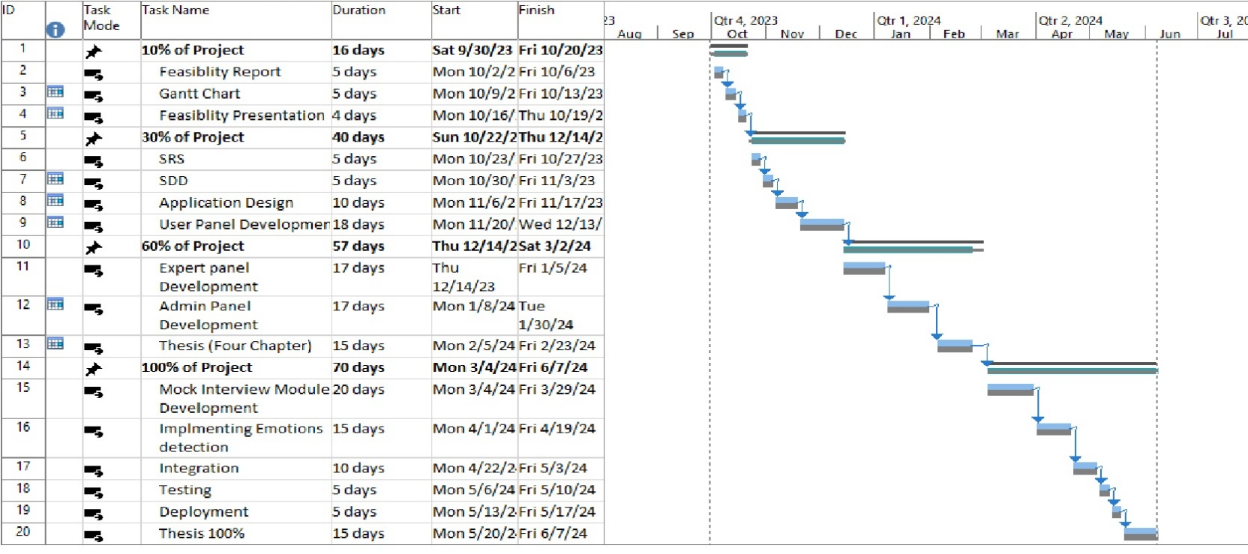**Gantt chart**

**Mockups:**

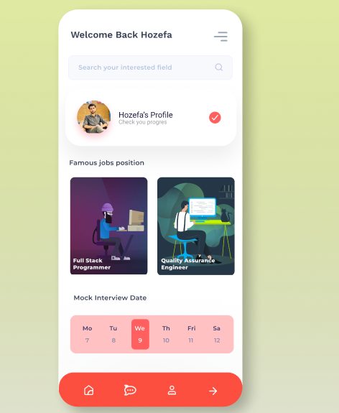

Figure 1: Home Screen (User Panel)

Figure 2: Mock Interview Module

Figure 4: Chat with experts (Expert Panel)

Figure 3: Expert Panel

**Conclusion**

To wrap it up, the "Interview Preparation Application" is a game-changer for software engineering graduates preparing for job interviews. It offers personalized learning, real-time expert help, and confidence-boosting tools. Our app creates a friendly community, provides lots of resources, and lets you see how you're doing step by step. This project's goal is to give graduates the skills they need to do great in software engineering interviews and kickstart their careers with confidence and ability.

**References**

1. [The Explicitation Interview: Examples and Applications: Ingenta Connect](https://www.ingentaconnect.com/content/imp/jcs/2009/00000016/f0030010/art00003)
2. [Software engineering education: The gap between industry's requirements and graduates' readiness | IEEE Conference Publication | IEEE Xplore](https://ieeexplore.ieee.org/abstract/document/5958974)
3. [OpenCV with Python | SpringerLink](https://link.springer.com/chapter/10.1007/978-1-4842-4261-2_2)
4. [Huru | #1 AI Interview Prep app | Immediate AI Feedback](https://huru.ai/)
5. [Emotion Detection with Facial Feature Recognition Using CNN & OpenCV | IEEE Conference Publication | IEEE Xplore](https://ieeexplore.ieee.org/abstract/document/9823786)

**Plagiarism Report**

Attach the Plagiarism report of your project scope document from library staff of turnitin tool (http://turnitin.com